Industrial Support Generation for P3 (Origin)
SRS
Shlomit Morad
29-Jan-2024
Table of Contents
1 Introduction 2
1.1 Terms & Acronyms 2
1.2 Support Strategy Overview 2
2 Support Profile Content 3
2.1 Anchor Points’ Parameters 3
2.2 Support Parameters 4
3 Support Generation Strategy 6
3.1 Struts-Specific Requirements 6
3.2 Scaffold-Specific Requirements 6
3.3 P2T vs. P2P 7
4 Support Profiles Management 8
4.1 Support Profile Changes 8
4.2 Support Profile Display 8
5 Manual Workflow Changes 10
5.1 Support Profile per Model 10
5.2 Anchor Points Panel 10
5.3 Anchor Points Display 10
5.4 Support Panel 11
5.5 Project Save and Load 11

Introduction
The support generation functionality (strategy, structures & parameters) vary significantly between dental & industrial models. The support generation for dental models is fully covered by the Basic Support generation as defined and implemented in Origin Phase I.
This document specifies the requirements for anchor points & support generation for industrial models in P3 printers. It does not specify functionality which remains the same as in the first phase.

Terms & Acronyms
This document uses the following terms & acronyms:
Part-to-Part (P2P) – a support structure who’s both edges contact the model
Part-to-Tray (P2T) – a support structure who’s lower edge contact the tray surface

Support Strategy Overview
The definition of the Support Profile made in the first phase assumed that a model would have a single support style (Scaffolds) in addition to Struts used when support height is below Max Strut Height.
Moreover, this definition assumed that all model parts can be supported from the tray.
This assumption was correct for dental models, but not for industrial models. Industrial models shall use different structures or the same structures with varying dimensions, based on the following considerations:
- How large/heavy is the part to be supported?
- How long is the support structure?
- How dense are the anchor points?
- How Part2Part support affects the part surface?
Some of these considerations can be detected by the software that shall change the support style accordingly (e.g. the support height or anchor points’ density). Other considerations (model weight or P2P effect of model surface) require the user’s judgement.
Therefore, each material may have multiple support profiles to be selected (manually) according to the model dimensions, its geometry, special requirements for surface quality, etc.

Support Profile Content
The support profile is composed of 4 sections:
- Anchor points’ parameters
- Global support parameters
- Part-to-Tray support parameters
- Part-to-Part support parameters
All length/height parameters are in mm; All angles are in degrees.
All parameters have no default value, unless else is specified.

Anchor Points’ Parameters

Self-Supporting Angle  (10-90) | The minimum allowed angle between the surface and the horizontal, which can be printed without support structures.  For surfaces with a lower angle, anchor points are added automatically. | Angle = self-supporting angle (e.g. 45°)  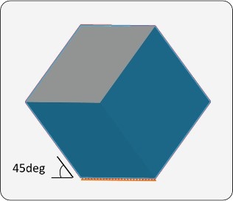 | Angle (44°) < self-supporting angle (45°)  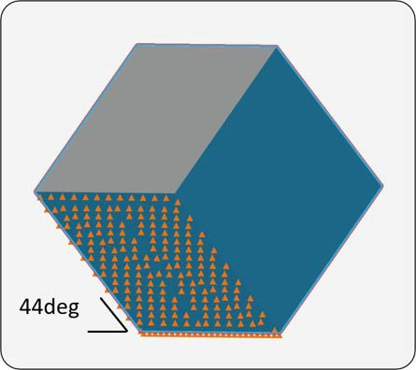
Border Point Spacing  (0.1-10) | The anchor point spacing from point-to-point along the border of a model. | Border Point Spacing – 3 mm  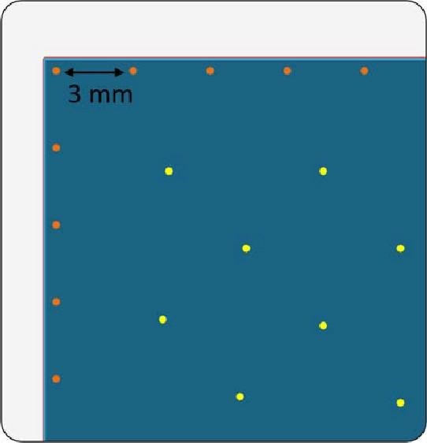
Interior Point Spacing  (0.1-10) | The anchor point spacing from point-to-point within the interior area of a surface of a model. | Interior Point Spacing – 4 mm  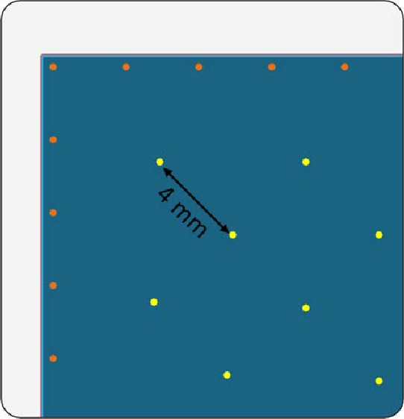
Border Offset  (0-10) | The distance between the border anchor points and the edge of a surface. | Border offset 0.25 mm  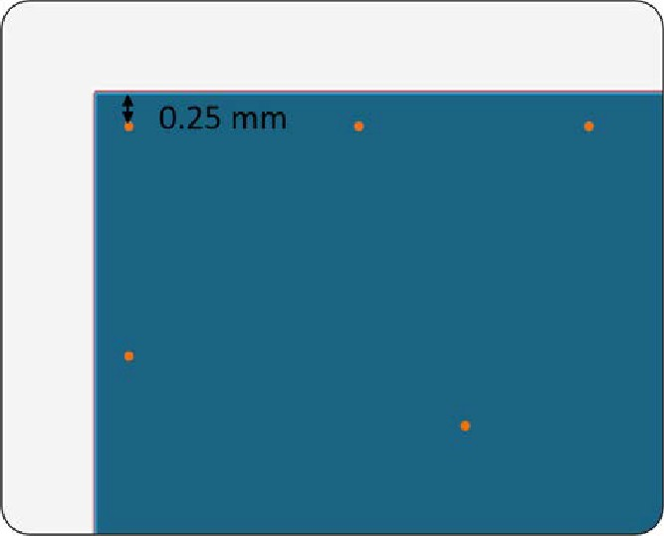 | Border offset 0.75 mm  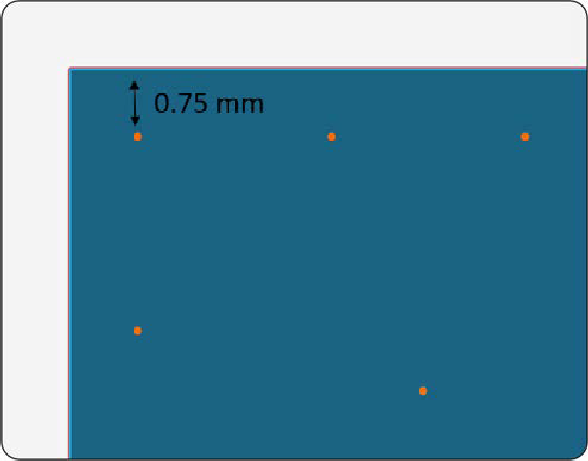
Overhang Offset  (0-10) | The maximum overhang length from the previous slice without needing support. | Overhang requires support when the Overhang Offset (1.5 mm) is less than the overhang (2 mm)  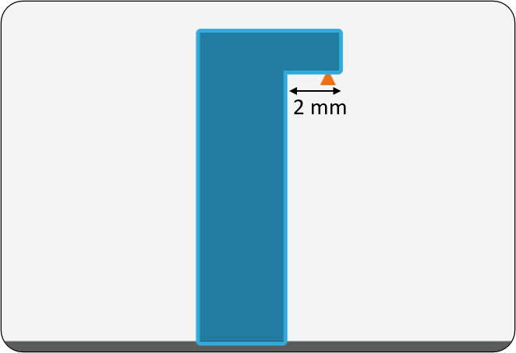 | Overhang does not require support when the Overhang Offset (1.5 mm) is the same as the overhang  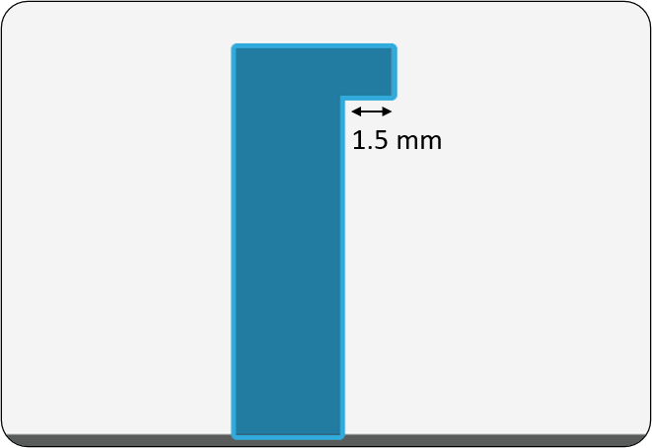
Max Corner Angle  Angle (>0 & <180;  0 to ignore) | For surfaces that are parallel to the platform, anchor points are placed in corners when the defined angle is below the angle of a corner. | 89° Max Corner Angle – places anchor points at the true corners  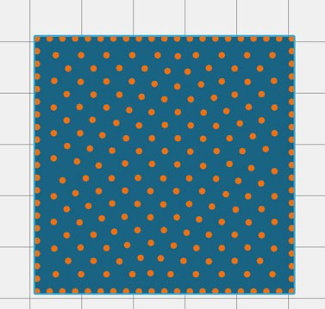
Additional parameters:
Extra Island Support checkbox with 2 dependent parameters:
- Island’s Supported Radius – Valid range: 0 or 0.5-10mm
- Island’s Interior Spacing – Valid range: 0 or 0.5-5mm

Support Parameters
- Support Critical Angle (30-90, should be >= Self-supporting Angle)
- Min Above Plate (0-20; > Pedestal Height)
- Pedestal Height (0-20; < Min Above Plate)
- Max Strut Length (1-100) – default is 10
- Global tip parameters:
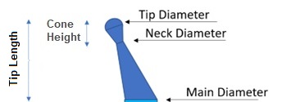

- Tip Diameter (0.1-10)
- Neck Diameter (0.1-10, should be <= Upper Tip Diameter)
- Cone Height (0.1-10)
- Penetration (0.1-0.5*Upper Tip Diameter)
- Normal Approach (checkbox)- default is clear
  - Normal Approach Length (0.1-20)
- Main Diameter (0.1-10, should be >= Upper/Lower Neck Diameter)
- Foot Diameter (0.1-10, should be >= Main Diameter)
- Strut parameters:
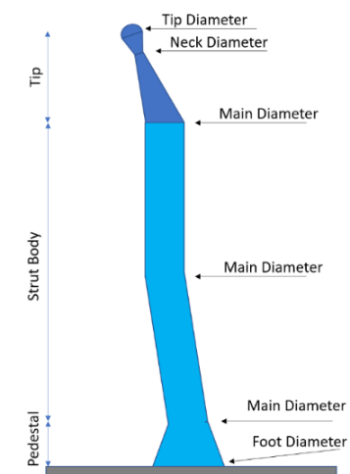

- Scaffold parameters:
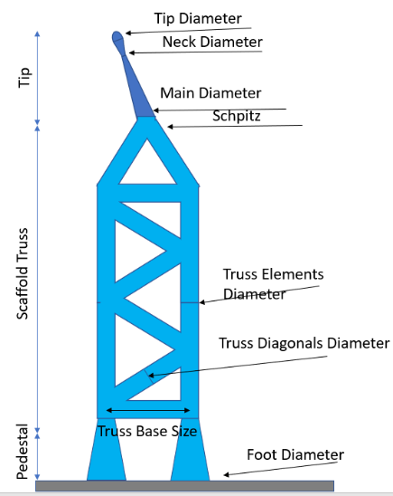
- Truss Box Size (0.1-10)
- Truss Elements Diameter (0.1-10; >= Main Diameter)
- Truss Diagonals
          - Truss Diagonals Diameter (0.1-10)
          - Truss Diagonals Angle (0-90)
- Max Scaffold Height (<100) – default is 99

Support Generation Strategy
The model support is composed of P2T & P2P elements. At this phase, they share the same parameters.
When GCP builds the support structure, it shall use the simple rule: Struts should be used for low support structures (<= Max Strut Length). Scaffold should be used for higher support.

Struts-related Guidelines
- Struts should be connected to the pedestal “corners” of the scaffold or pedestal.
- The struts should be equally divided (as possible) among the scaffold/pedestal beam corners (do not overload a certain corner with more struts than others).
- Struts should be perpendicular to the tray whenever possible.

Scaffold-Specific Requirements
There are 3 special cases regarding scaffolds:
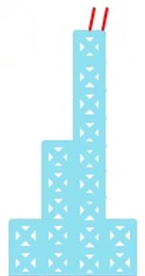
- If the Support height > Max Scaffold Height: the scaffold should be strengthened with supporting scaffolds in all 4 sides:
The height of the supporting scaffolds shall not be longer than the Max Scaffold Height
Repeat this process until you have a supporting scaffold whose height is below the maximum.
- A diagonal scaffold must be self-supported.
- The lower contact of a P2P Scaffold must have at least 3 struts. Else, the scaffold might be unstable (thus not supporting as required.

P2T vs. P2P
Many anchor points can be supported by both P2T and P2P support structures:
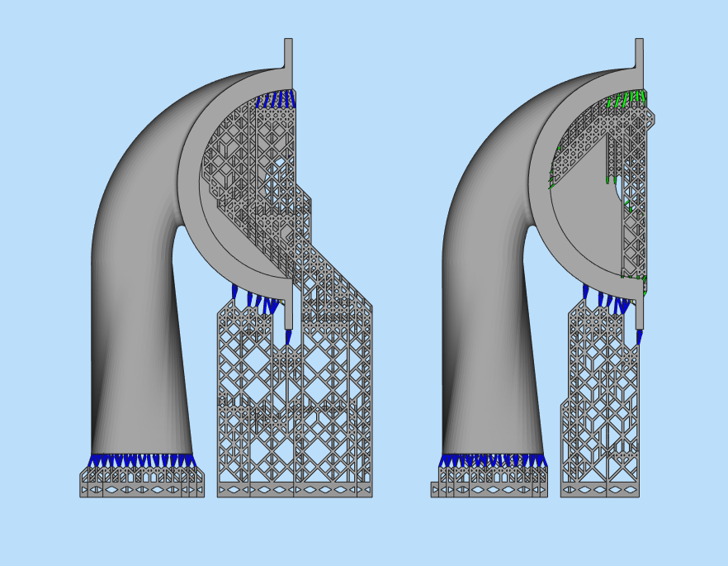
- P2T support might require massive structures that use much material, but it may leave the model surface as “clean” as possible.
- P2P support will usually be smaller (and less material is consumed), but the model surface will have more support touchpoints.

At this phase, GCP should create as much P2T support as possible, even if it requires massive/diagonal structures. It shall create P2P support only for those points that cannot be supported otherwise.

Support Profiles Management
The support profiles management remains as defined in the basic support spec. The only change is the profile content. The different content requires changes in the support parameters display while viewing, adding or modifying an industrial profile.

Support Profile Changes
The following changes were made to industrial support profiles:
- No orientation section – the orientation shall be made via the Orient panel.
- A new Anchor Points mechanism requires different parameters.
- The support parameters are divided into Part-to-Tray and Part-to-Part sections. Each section has dedicated global parameters.
- Each profile shall define all support structures (Struts, Scaffolds) for both P2T & P2P.

Support Profile Display
By default, the profile shall be opened Collapsed. Since the industrial profile contains only Anchor Points and Support parameters, it will be collapsed at a lower level than the Dental profile:
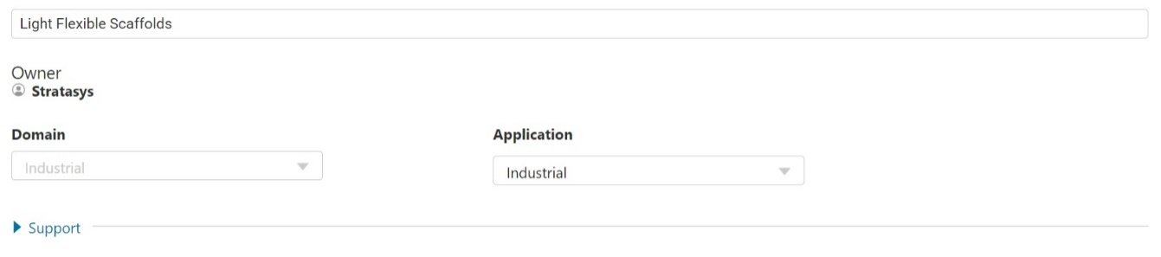
The user shall be able to expand each section separately.
Anchor Points
The following image present the new anchor points’ parameters:
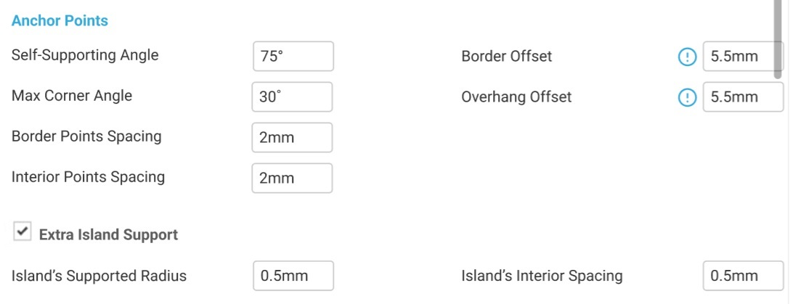

Support
The following images present the support parameters for struts & scaffolds:
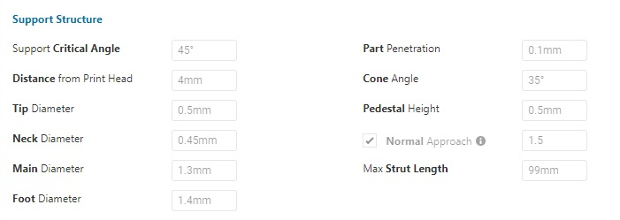

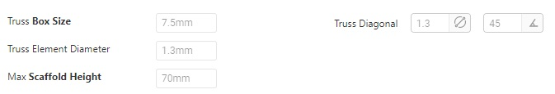

Manual Workflow Changes
This section describes the changes to the manual print preparation workflow for an industrial tray.

Support Profile per Model
The Model Settings dialog is added to allow the user selecting a different support profile per each model (usually based on geometry, weight, etc.).
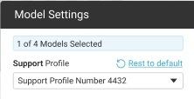
With the Reset to Default button, the user can reset the model profile to the default profile selected for the tray.

Anchor Points Panel
The Anchor Points panel should be modified with the new parameters:
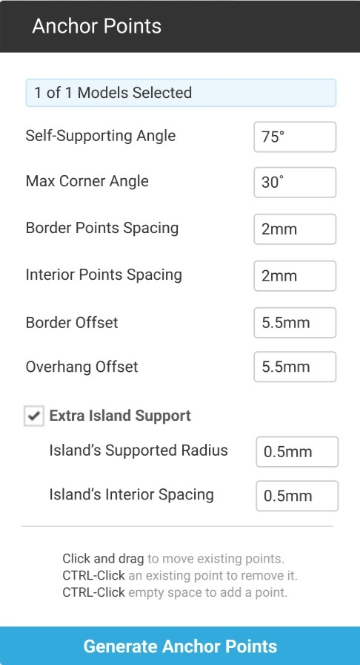
When the anchor points are generated, GCP shall move into a “Support Mode”, in which the user shall be able to modify, delete and add anchor points (see the last chapter).
When the user modifies Anchor point parameters:
- An asterisk is appended to the support profile name.
- The user can reset to the original profile values using the Reset to Profile button.
- If the model already has anchor points and/or support, they will be removed.

Anchor Points Display
Today, GCP colors the anchor points in 3 colors:
Orange – the anchor points when generated, and anchor points that have support structure
Yellow – a selected anchor point
Purple – manually added/moved anchor points
Red – non supported anchor points (after support was generated)

Support Panel
The support parameters shall be composed of the same sections as in the profile. By default, the panel shall be opened collapsed (at the same level as in the Materials & Profiles module):
The images below show the global support parameters and scaffold parameters:
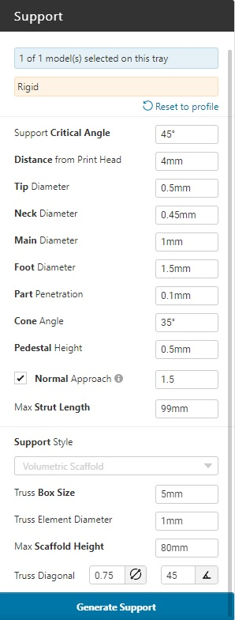
The support panel shall allow the user to override specific parameters for the model support. When he modifies support parameters:
- An asterisk is appended to the support profile name.
- The user can reset to the original profile values using the Reset to Profile button.
- If the model already has support, it will be removed.

Project Save and Load
At any point during this workflow the user can save the project. The saved .print file should include the support profile selected per model.
Since the user may use a private (custom) support profile, another user that loads this project will not have it. In this case, leave the profile name empty, forcing the user to select a new profile. It is relevant for both Tray support profile and Model support profile.
Since the support profiles are managed locally, two users might have the same support profile name. Therefore, if the support profile is private (not SSYS), verify that the profile owner = the current user. If the owner does not match, leave the support profile name empty.

